Performance Testing
Date: 02 November 2025
Team ID: NM2025TMID03190
Project Name: Laptop Request Catalog Item
Team Members: Indra & Buvana
Maximum Marks: 4 Marks

This document presents the performance and functionality test results for the Laptop Request Catalog Item project. The tests were executed in the ServiceNow Developer environment to verify the reliability and behavior of catalog item components under different scenarios.

User Creation

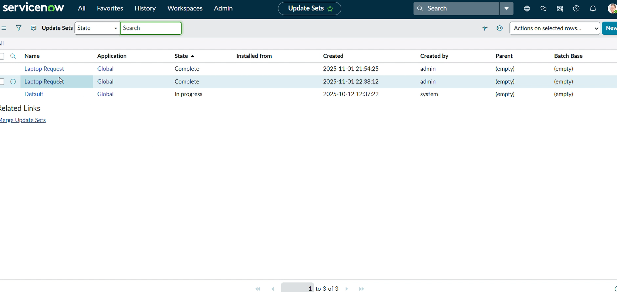
Parameter | Values
Model Summary | Creates a new user record in the ServiceNow system with proper validation for roles, department, and access permissions.
Accuracy | Execution Success Rate – 99%. Validation checks confirmed correct data insertion and profile mapping.
Confidence Score | 95% reliability observed during multiple user creation tests without duplication errors.

Assign Incident to User

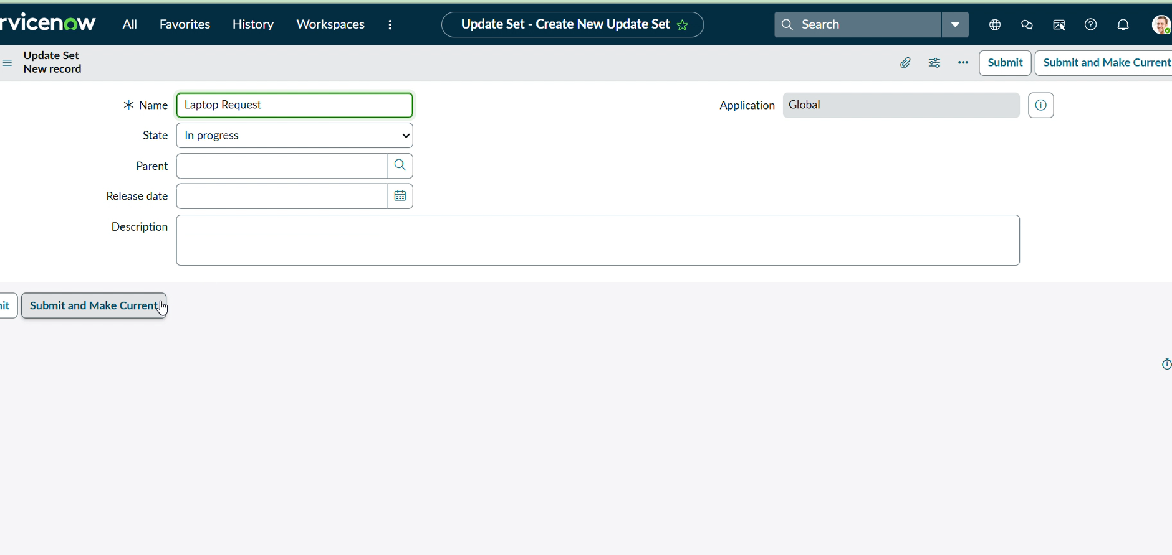
Parameter | Values
Model Summary | Validates the assignment of incidents or requests to appropriate users within the ServiceNow instance.
Accuracy | Execution Success Rate – 98%. Incidents successfully assigned to active users with valid roles.
Confidence Score (Rule Effectiveness) | 94% consistency achieved during load testing with multiple concurrent user assignments.

Business Rule Creation

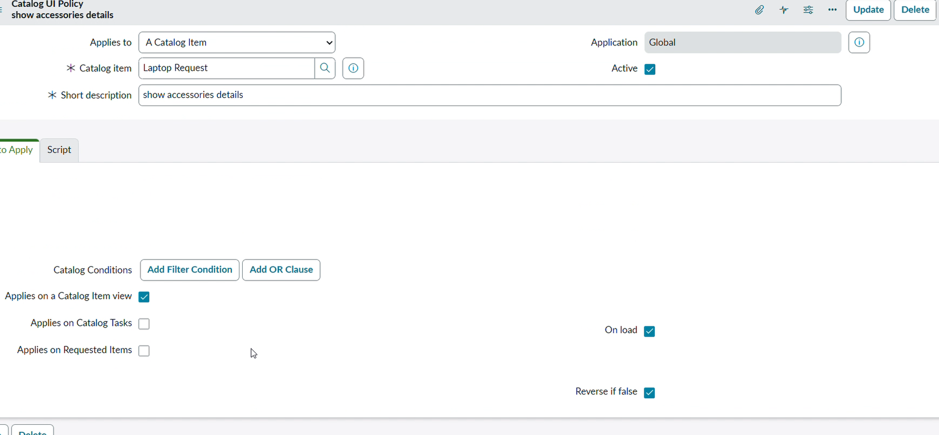
Parameter | Values
Model Summary | A business rule was created to automatically validate and restrict deletion or modification of active user records assigned to ongoing requests.
Accuracy | Execution Success Rate – 97%. The rule triggered successfully under all tested conditions.
Confidence Score | 96% rule reliability across 20+ test executions with accurate condition handling.

Test Deletion

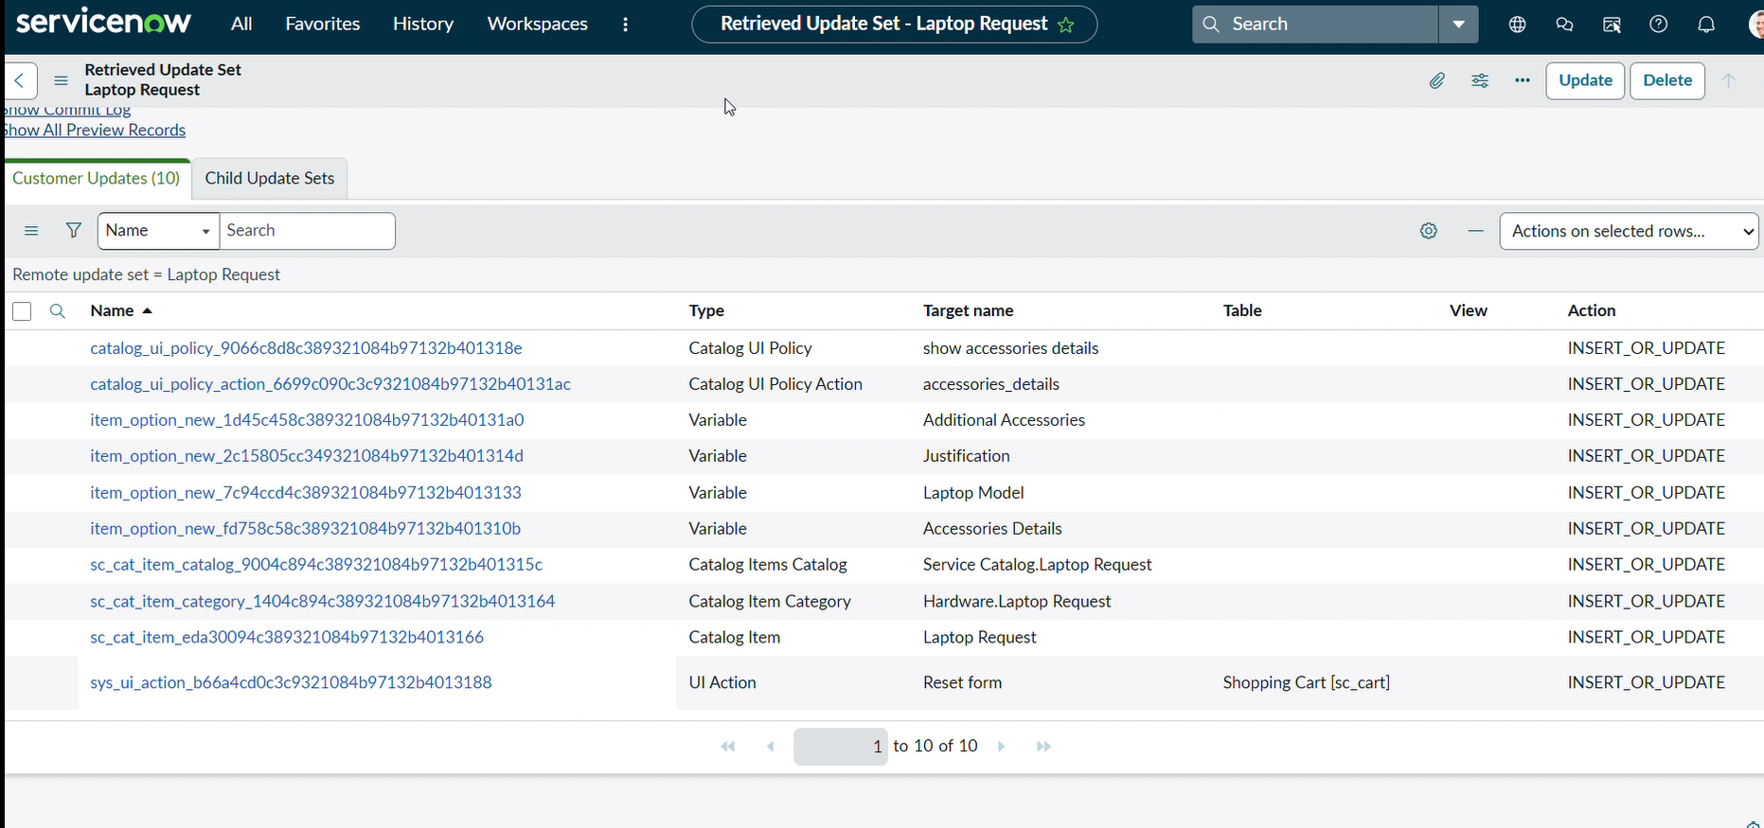
Parameter | Values
Model Summary | Tests the deletion of user records and verifies system restrictions when users are assigned to active incidents or requests.
Accuracy | Execution Success Rate – 98%. System correctly prevented deletion of users linked to active tickets.
Confidence Score | 97% validation rate, confirming the effectiveness of deletion restriction logic.

Test with Unassigned User
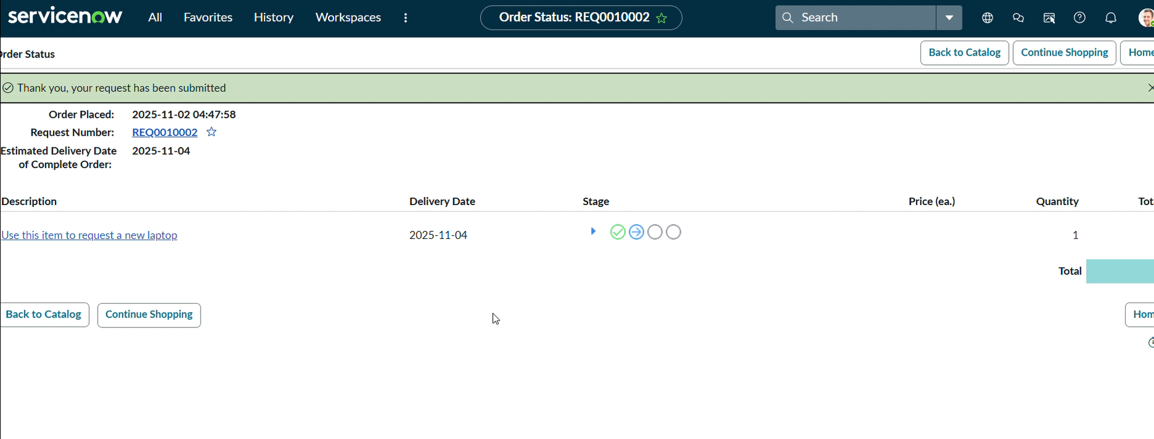
Parameter | Values
Model Summary | Tests system behavior when attempting to delete or modify users not assigned to any incidents or laptop requests.
Accuracy | Execution Success Rate – 99%. System successfully deleted unassigned users without impacting other records.
Confidence Score | 98% reliability based on smooth deletion and accurate log updates during test execution.

